**PHASE 1 PROJECT REPORT**

**Generic Team Name**

**William Wang**

**YuChen Zeng**

**Robert Beck**

**Michael Berezanich**

**JingRui Duan**

## 

**Table of Contents**

**1. Introduction** **4**

**2. Requirement Analysis** **6**

2.1 Auction Items 6

2.1.2 Categories 7

2.2 Users 7

2.2.1 Registered Users 8

2.2.2 Companies 8

2.3 Ratings 8

2.4 Browsing 9

2.5 Searching 9

2.6 Bidding 9

2.7 Buy It Now 10

2.8 Auction Statistics 10

2.9 Delivery 11

2.10 Reports to Telemarketers 11

2.11 Mechanic Certifications 11

2.12 Deal Rating 12

2.14 Discussions 12

2.15 Display Floor 13

**3. Conceptual Database Design** **14**

3.1 Entities 14

3.1.1 Users 14

3.1.2 Vehicles 15

3.1.3 Bank Accounts 15

3.1.4 Reviews 15

3.1.5 Auctions 15

3.1.6 Bids 15

3.1.7 Transaction 16

3.1.8 Discussions 16

3.1.9 Display Floor 16

3.1.10 Events 16

3.1.11 Media 16

3.2 Relationships 17

3.2.1 Money In 17

3.2.2 Owns 17

3.2.3 List for Auction 17

3.2.4 Rates 18

3.2.6 Closed 18

3.2.7 Returned 18

3.2.8 Delivered 18

3.2.9 Uploads Media 19

3.2.10 Belongs To 19

3.2.11 Post Discussion 19

3.2.12 Create Event 19

3.2.13 Attending Event 19

3.3 All Together 20

**4. Conclusion** **21**

**Appendix A: Progress Reports** **22**

**Appendix B: Project Plan** **26**

## 

**List of Figures**

Figure 1.1 Graph of automobile sales by year; Bureau of Economic

Analysis;Visualized by Business Insider

Figure 1.2 Graph of percentage of total retail sales e-commerce makes;

Department of the Census Bureau;

United States Department of Commerce

Figure 2.1 Vehicle Category Tree

Figure 3.1 Users ISA Hierarchy

Figure 3.3 Vehicle e-Auction ER Diagram

## 

# **1. Introduction**

This document is the Phase 1 report for our database-backed Vehicle e-Auction web application project. This Phase 1 report covers the Requirement Analysis and Conceptual Database Design.

The goals of this Phase 1 report are fully analyzing the features and functionalities of the Vehicle e-Auction web application; providing a detailed conceptual design for the back-end database system.

According to the United States Department of Commerce, the United States has one of the largest automotive markets in the world. Light vehicles sales alone reached 17.5 million units in 2016. Overall, the United States ranks the second largest market for vehicle sales. [1] As shown in Figure 1.1, automotive sales is experiencing a steady positive trend in sales. Furthermore, Figure 1.2 shows the rising percentage of e-commerce retail sales. It is very clear that Hilbert Dude’s vision in building a online e-commerce for automotive sales is a great investment.

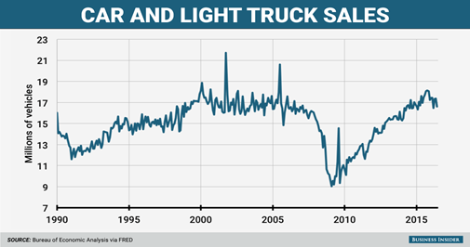

**Figure 1.1 Car and Light Truck Sales**

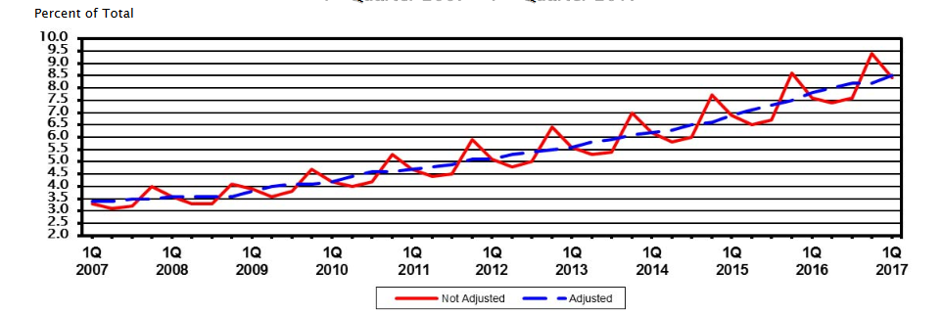

**Figure 1.2 The Rising Percentage of online retail sales**

After this Vehicle e-Auction web application is fully tested, the final product will be delivered to the investor Mr. Hilbert Dude.

Section 2 provides requirements analysis in terms of features and functionalities analysis. Section 3 gives the conceptual database design for the back-end database. This project report is an ongoing document. It will be augmented in Phase 2 and will be fully completed during the Phase 3.

## 

# **2. Requirement Analysis**

After the several communicating with Mr. Dude, the project team has a solid understanding about his vision in e-commerce and his expectations for the Vehicle e-Auction system. The team has performed a thorough requirements analysis. This section provides detailed descriptions for the features and functionalities of the Vehicle e-Auction system. The conceptual database design of the back-end database will be given in section 3.

## 2.1 Auction Items

Automobiles will be sourced from the users themselves. The website allows registered users (detailed in Section 2.2) to post their automobiles for cataloging. Accompanying each product entry will be short descriptions limited by 400 character length, personal URLs providing more specifics, photos, and location (state). Even though this system is primarily an auction website, the website needs to be able to homogenize itself within the automotive community allowing users to be able to connect with each other. This facilitates automotive shows and socials which furthers the network of users within the **e-Auction** community. Thus, the website does not mandate all postings to become auctionable items. However, if the registered user decides to list a product to be auctioned, a reserve price, buy it now price, auction period, and shipping location is attached to the seller’s vehicle. In more detail, the reserve price is a price set by the seller which determines the threshold when the seller is obligated to sell at the auctioned price. In other words, if the highest auction price at auction closing does not meet or exceed the reserve price the seller is not obligated to sell the product.

### **2.1.2 Categories**

Since **e-Auction** provides a platform for peer to peer commerce. A predefined set of categories will be in place to facilitate users in cataloging their vehicles. Since this system focuses primarily with automobile transactions, the root of the catalog are automobiles. Shown in Figure 2.1 is a breakdown of the categories.

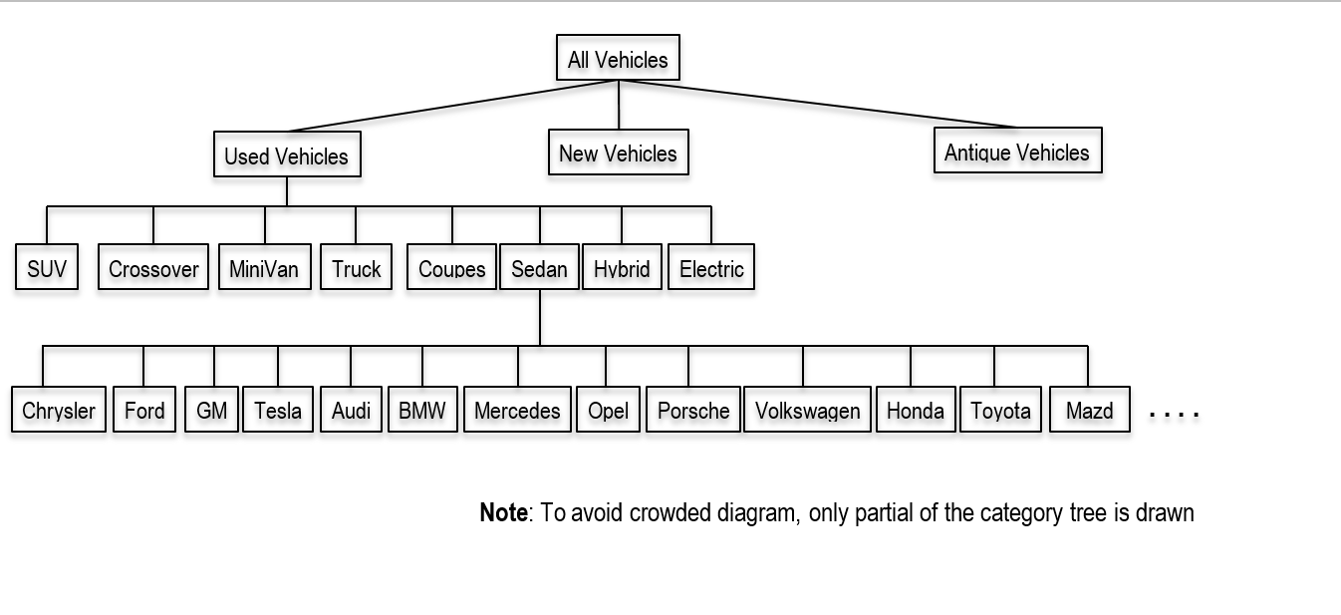

**Figure 2.1 Vehicle Category Tree**

## 2.2 Users

The target audience for this website are automobile owners, buyers, and dealers (detailed in Section 2.2.2) as well. Aforementioned, **e-Auction** promotes not only the transaction aspect of the automobile community but also the community and its social aspects. Thus unregistered users are allowed access to this community but are limited to only browsing(detailed in Section 2.4) and searching(detailed in Section 2.5). In order to take advantage of the full sets of features the **e-Auction** community has to offer, the user must become a registered user (detailed in Section 2.2.1).

### **2.2.1 Registered Users**

In order to become a registered user, one must register an account. Each account is identified by a user name and authenticated by a password. Additionally, an account consists of an email address, name, address/es ( street, city, state, and zip), phone number, bank account/s (account number and routing number), age, gender, and annual income. After confirmation of a successful registration, the user will be able to list items to become cataloged, bid on auctions, and sell their listings to become auctioned. Additionally, the user will be allowed to edit a personal bio page to provide a background. To cater to the community aspect, registered users will have the privilege to post and respond to discussions within the forums section of the website.

### **2.2.2 Companies**

Companies which express interested in using this platform must also register as a user. However, only after confirmation of the existence and proper licensing of the respective dealership may companies become active members. Upon successful confirmation, all dealership accounts are identified by username and authenticated by password likewise to registered users. However, dealership accounts are maintained with information about company name, main point of contact, address, phone number, revenue, dealership categories(ie. Luxury, Exotic, Brand, etc.) and dealership age. These accounts inherit the same privilege as normal registered users; however, all listings must be posted as auctionable items.

## 2.3 Ratings

All registered users within their bio page contains a mandatory public rating and reviews section. This system is used to prevent scams and item fraud within the **e-Auction** community. In order for a registered user to be eligible to leave ratings on another user’s bio page, the reviewer must have participated in a past reviewed user’s auction. The system is comprised of a scale out of ten accompanied by a short explanation with a 250 character limit.

## 2.4 Browsing

Mentioned in Section 2.2, guests (unregistered users) only have the privilege to browse **e-Auction**. Thus guests and users will be able to traverse through the category tree to view the catalog of vehicles within the database. Within each level of the category tree, the user is presented with a description of the category as well as a summary of all items within that category. As the user goes deeper and deeper into the category tree, listings become much more specific and less broad thus limiting the resulting summaries. However, guests will not be able to bid(detailed in Section 2.6) on a vehicle they are browsing. Allowing guests to browse **e-Auction** helps attract new users and potentially gain more customers.

## 2.5 Searching

All users are able to search the system for specific vehicles. To search, users are able to input keywords or select conditions. For example, conditions may be as specific as a combination of brand, model, condition, and year range. After inputting the search parameters, a list of vehicles which satisfies the search will be listed for the user to browse. The searching method provides a much more detailed manner for users to browse for products. As mentioned in the previous sections, guests are still restricted to bid on vehicles they are browsing.

## 2.6 Bidding

Only registered users and non-dealers may place bids on items which are not theirs during the designated auction period. Since there is a reserve price for each item auctioned, the starting price will begin at 0 dollars. A user may only bid prices which are 5% above the current highest bid price and are not restricted in the number of bids. The bid price restrictions promotes competitive prices for items. After each change in highest price, all users who participated in the auction will be notified of the new price as well as who leads the auction in highest price. When the auction period is over, all participating users will be notified of the winner and winning price; additionally, contact information is sent to both the buyer and seller. Furthermore, the auction will transition into the delivery (detailed in Section 2.9) phase.

## 2.7 Buy It Now

Accompanying each auctioned vehicle, there is an option to purchase the vehicle at a “Buy It Now” price, determined by the seller. This feature allows users to skip the auction period and bidding processes attaining the vehicle at a premium. After confirming that a user is using the “Buy It Now” method instead of bidding, all bidders will be notified of the auction closing early, who won the vehicle, and the winning price (“Buy It Now” price). Contact information is sent to both the buyer and seller; the auction will transition into the delivery (detailed in Section 2.9) phase.

## 2.8 Auction Statistics

Weekly reports are made for each category of items. The reports summarize the statistics of the items. These reports help determine trend in value of categories not only by a small weekly view but also monthly, seasonal, and yearly. These statistics help **e-Auction** to determine trends in depreciation and inflation of value. For example, a winter coat may be cheaper in the summer than it is in the winter. This type of statistics help sellers as well as buyers to determine when to auction an item.

## 2.9 Delivery

The final and most important stage of an auction’s life cycle is delivery. To ensure the successful movement of goods and transfer of money, **e-Auction** serves as the medium where both money transfer and vehicle shipping is conducted. At the end of an auction, the seller will have a 2-week window to transfer the vehicle to one of **e-Auction** holding sites. Likewise, the buyer’s bank account will be notified to transfer the proper amount of money to **e-Auction** within the 2-week window as well. Once **e-Auction** confirms the arrival of both the funds as well as the vehicle within the window period, the vehicle will be transferred to the buyers address and the money will be deposited to the seller’s bank account. On the other hand, if there is no successful confirmation of both the funds and vehicle arriving within the 2-week period. The transaction is deemed as void and items which **e-Auction** received will be forwarded back to the respective owners. Both parties will be notified whether the delivery was successful or voided. These information will be stored for a six month period time after notifications are sent.

## 2.10 Reports to Telemarketers

Telemarketers will receive details of the users behaviors. Included in these reports will be the name, address, email, age, gender, and annual income. These information will be given privately without user knowledge. Thus when users register for accounts the telemarketing report information is required.

## 2.11 Mechanic Certifications

Sellers have the option to have their vehicle appraised and evaluated by one of **e-Auction** certified mechanics. The certified mechanic recommends users the current market price as well as a holistic vehicle report. These reports are attached with the VIN of the vehicles and are available for buyers to view. After an auction closes and transitions to the delivery phase, all vehicles will go through a holistic report from a certified mechanic on site. If the vehicle’s description is deemed misleading or fraudulent by the certified mechanic, the transaction is deemed void and a 20% penalty is charged to the seller.

## 2.12 Deal Rating

With weekly auction reports, significant amount of data is gathered through the lifetime of the website. This allows for holistic analysis of auctioned products. These statistics allows users to adjust their reserve and “Buy It Now” prices according to the value of their product. Additionally, these statistics are displayed in the vehicle summary to foster competitive auctions. Buyers will be able to have a feel of which vehicle better suits their long term and short term budgets.

## 2.14 Discussions

To cater to the social aspect of the automobile enthusiast community, **e-Auction** provides a social discussion driven platform for registered users. As mentioned, guests may browse and search for relevant discussions but are restricted from posting and responding. The Discussion sections is separated into two parts: auction questions, and topics. Auction questions provides a platform for buyers to post questions about an auctioned vehicle as well as sellers to post responses and announcements. On the other hand, the topics portion of the discussions feature is a topic driven social platform which promotes users to ask general questions whether it be maintenance concerns, car ownership stories, etc.

## 2.15 Display Floor

The display floor allows users to proudly display their vehicle. The display floor accompanies each vehicle and provides a medium for users to upload images and videos which highlights the beauty and features of their vehicle. This allows buyers to be able to have a virtual tour of the vehicle as well as users to display their collection.

# 

# **3. Conceptual Database Design**

This section details the technical model for **e-Auction**’s database. The database will be modeled using the ER-Model, entity relationship model. The following subsections will describe the entities, relationships, and full diagram of **e-Auction**’sER-Model. Additionally, each subsection will highlight the assumptions and constraints.

## 3.1 Entities

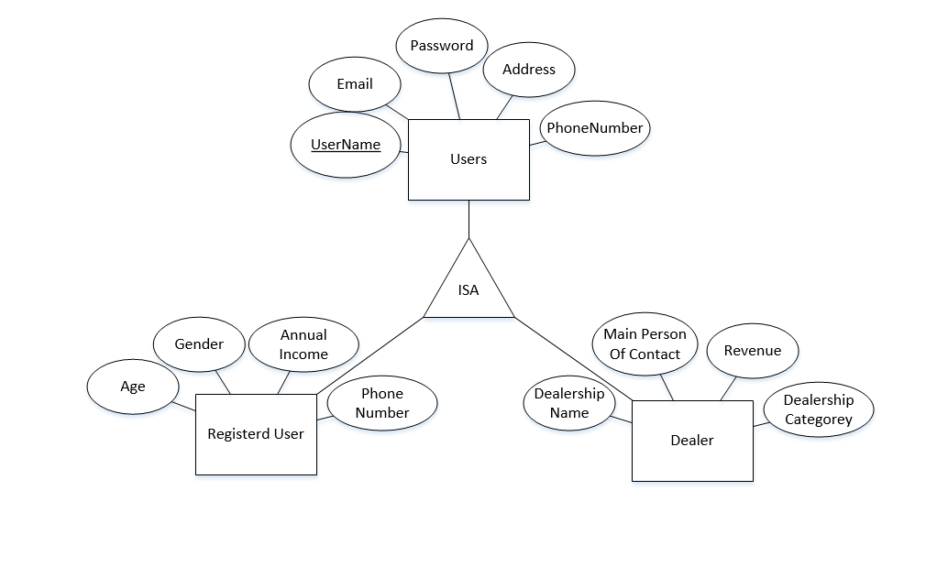

**Figure 3.1 Users ISA Hierarchy**

### **3.1.1 Users**

The user entity is a set of all users with registered accounts within the **e-Auction** community. However, detailed within the requirement analysis, there is a separation between users. A user can can either be a Dealership or a registered user. Thus an ISA hierarchy will be implemented to differentiate the two entities. Thus the hierarchy can be described as follows: **User** is a **Dealer** or **User** is a **Registered User**. Figure 3.1.1 describes the ISA structure and entities in more detail.

### **3.1.2 Vehicles**

The vehicles entity is a set of all vehicles which users catalog. The vehicles entity set is identified by VIN (Vehicle Identification Number) and have attributes: category, make, model, year, mileage, description. Vehicles is not a weak entity set because e-Auction stores data for long term analysis.

### **3.1.3 Bank Accounts**

Since **e-Auction** directly deals with money transfers, many users may have allocated money in various accounts. To accommodate this, bank accounts entity is a weak entity associated with the users entity. This allows users to enter multiple bank accounts to pay for items they have won. Additionally, Bank Accounts is a weak entity due to privacy and security concerns to protect users. Table 3.1.3 describes the bank accounts weak entity in more detail.

### **3.1.4 Reviews**

Each user can post a review for auctions the user was involved in. The buyer can post a review to rank the seller and the seller also can post a review to rank the buyer. The reviews entity set is identified by the review ID; other attributes: date, auction ID, ranking, review.

### **3.1.5 Auctions**

Auctions entity is the set of all auctions. This entity is identified by auctionId and has attributes: VIN, end date, reserve price, buy it now price.

### **3.1.6 Bids**

Users can place any number of valid bids on any day. The Bids entity set is identified by the bid id and have attributes: bidder username, auction ID, price, timestamp.

### **3.1.7 Transaction**

Transactions entity set records all valid transactions. Transaction entity set is identified by transaction id, seller username, buyer username, VIN, price, date.

### **3.1.8 Discussions**

The discussions entity is part of the social aspect of **e-Auction**’s car community. This is broken down by ISA hierarchy with auction questions entity and topics entity. Auction Questions is for both seller and buyers to post messages. Buyers can post questions and comments to the seller and seller can answer questions. Topics are for all users to discuss about miscellaneous topics. Figure 3.1.8 and Table 3.1.8 describes this ISA hierarchy in more detail.

### **3.1.9 Display Floor**

Display floor allows users to upload pictures and videos of the vehicle. Users can browse the pictures and watch videos. The display floor entity set is identified by VIN, and have attributes: title, url.

### **3.1.10 Events**

Events entity is another part of the community aspect. Events are user created and are identified by eventID with attributes: event name, date, address, and category.

### **3.1.11 Media**

Media entity is a set of all media files users uploads. Media is identified by fileID and has attributes: type, name, date.

## 3.2 Relationships

### **3.2.1 Money In**

The Money In relationship is a weak relationship associating the weak entity set Bank Account to Users. It is mandatory for users to input at least one bank account to register for an account. Thus, within the Money In relationship, total participation constraint is applied to the Users entity set. On the other hand, bank accounts can not be shared among multiple users, a key constraint and total participation constraint is applied to the Bank Account weak entity set. Table 3.2.2 and Figure 3.2.2 describes this entity in detail.

### **3.2.2 Owns**

**e-Auction** allows registered users to input vehicles to catalog within its database. Thus a relationship arises between registered users and vehicles. This relationship does not mean that users are selling the vehicle. This relationship essentially allows proud owners to display their collection of vehicles to the **e-Auction** community. Within this relationship, a key constraint is placed onto the vehicles set. These constraints are placed because a vehicle can only be listed by one owner.

### **3.2.3 List for Auction**

The main focus of **e-Auction** is to foster a platform for peer to peer commerce. Thus the list for auction relationship associates the users entity set to vehicles entity set. A key constraint is placed upon the auctions set due to the fact that every auction can only have one seller.

### **3.2.4 Rates**

Users are allowed to rate other users who have participated in an auction together. Since the system is designed for users to rate users, this relationship is tenery involving a two way association of users entity set and an association with reviews entity set.

**3.2.5 Place Bids**

Registered users can place any number of valid bids on auctions before auction close. Place bids is a ternary relationship associating registered user entity, bids entity, and auction entity.

### **3.2.6 Closed**

When a vehicle auction end date is reached, all bids for the vehicle will be checked to announce the winning bid if there is any. Closed associates bids entity and auctions entity with descriptive attribute validity.

### **3.2.7 Returned**

To ensure buyer satisfaction, certified mechanics at **e-Auction** will examine the vehicle to certify that the seller description is valid. If the vehicle is deemed faulty, the vehicle is returned to the seller and a 20% penalty fee is applied, the transaction is deemed void. Additionally, if the either the money or vehicle did not arrive in the 2-week period, the received item will be returned and the transaction is deemed void. The returned relationship uses closed relationship as an aggregation and associates it with user entity and vehicle entity.

### **3.2.8 Delivered**

The delivered entity associates closed auctions and transactions.

### **3.2.9 Uploads Media**

A seller can upload multiple pictures and videos of the vehicle to the display floor. Uploads media relationship associates user entity with media entity.

### **3.2.10 Belongs To**

The display floor contains media files for users to browse. Belongs To relationship associates media entity with display floor entity.

### **3.2.11 Post Discussion**

Users can post discussions. Post Discussion relationship associates users entity and the discussions entity.

### **3.2.12 Create Event**

Users can create events for the community to see. Create Event relationship associates user entity and event entity.

### **3.2.13 Attending Event**

Users can attend events listed within the community. Attending Event relationship associates users entity and event entity.

## 3.3 All Together

**Figure 3.3 Vehicle e-Auction ER Diagram**

# 

# **4. Conclusion**

With the completion of Phase 1, the requirement analysis and conceptual database design, and this accompanying report, our group will be moving on to Phase 2. Phase 2 is where we will be finalizing the schema for **e-Auction**, based on the requirements and ER model presented in this report. Note that our model may change between Phase 1 and Phase 2 based on the feedback provided by the instructors.

The report for Phase 2 will primarily be filled with information on how we plan to create our final design and why. One portion of the report will be filled with the exploration of possible technologies we could use for our design, ending in a decision and our reasoning for it. However, most of the report for Phase 2 will consist of the SQL statements that we’ll use to create the relations in our database and to populate our database with sample data.

# 

# **Appendix A: Progress Reports**

**Group Progress Reports**

**Group:** Generic Team Name **Reporting Period:** 2/4/2018

|  |  |  |  |
| --- | --- | --- | --- |
| **Group Meetings** | **Attendance** | **Date/Time/Location** | **Duration** |
| Discussed the breakdown of the presentation and worked on the slides supporting it. | Present:  William  Yuchen  Rob  Missing:  JingRui  Mike | 2/4, 12:30pm W204 Westgate Building | 2 hrs |
| The writing of the project report. Yuchen came to help William write the project report. Yuchen was tasked to work on the Introduction. | Present:  William  Yuchen  Missing:  JingRui  Rob  Mike | 2/3 , 10:00pm W204 Westage Building | 2.5 hours |
| Determine the exactly what entities were needed. | Present:  Yuchen  William  JingRui  Rob  Mike  Missing: | 2/1, 7:30pm W204 Westgate Building | 2 hours |
| **Group Total Hours** |  |  | 6.5 |

**Signature:**

William Wang

Yuchen Zeng

Robert Beck

Mike Berezanich

**__________________________________________________________________________________________________________________**

**Group:** Generic Team Name **Reporting Period:** 1/28/2018

|  |  |  |  |
| --- | --- | --- | --- |
| **Group Meetings** | **Attendance** | **Date/Time/Location** | **Duration** |
| Began discussing the conceptual diagram | Present:  Yuchen  William  Missing:  JingRui  Rob  Mike | 1/28, 3:30pm Pattee Library | 2 hour |
| **Group Total Hours** |  |  | 2 |

**Signature:**

William Wang

Yuchen Zeng

**__________________________________________________________________________________________________________________**

**Group:** Generic Team Name **Reporting Period:** 1/21/2018

|  |  |  |  |
| --- | --- | --- | --- |
| **Group Meetings** | **Attendance** | **Date/Time/Location** | **Duration** |
| Initial team meeting. Discussed the requirements for the project including which additional features we plan to add. Decided on cars as a topic for our site, and a few of the technologies we plan to use (Bootstrap, MySQL, Python, PHP). Set up a Github for our project. | Present:  Rob  Mike  Yuchen  William  Missing:  JingRui | 1/20, 3:30pm Discord | 1 hour |
| **Group Total Hours** |  |  | 1 |

**Signature:**

Michael Berezanich

William Wang

Robert Beck

Yuchen Zeng

**Individual Progress Reports**

__________________________________________________________________________________________________________________

**William Wang**

|  |  |  |
| --- | --- | --- |
| **Date** | **Hours** | **Activities** |
| 2/4 9:00pm | 3 | Wrote Appendix C and finalized the report through formating |
| 2/4 2:30pm | 5 | Added more subsections to Section 2: Unique features. Refined Section 3 with needed entities, and relationships. Reworked the ER-model Diagram. Drew the Category tree. |
| 2/4 12:30pm | 2 | Worked with Rob, and Yuchen on the presentation formatting and slide. |
| 2/3 10:30pm | 2 | Worked with Yuchen on the Introduction. Helped him edit his introduction which properly expresses his thoughts in english. |
| 2/3 4:30pm | 6 | Worked on Sections 2 and 3 of the Project Report. Drew the preliminary ER model as a first draft. |
| 2/1 7:30pm | 2 | Determine exactly what entities were needed. With the whole group. |
| 1/28, 3:30pm | 2 | Began discussing the conceptual diagram with Yuchen |

**_________________________________________________________________________________________________________________**

**Yuchen Zeng**

|  |  |  |
| --- | --- | --- |
| **Date** | **Hours** | **Activities** |
| 2/4, 11pm | 1 | Format Phase 1 Report Final Draft |
| 2/4, 12:30pm | 3.5 | Making powerpoint and prepared presentation |
| 2/3, 10pm | 2.5 | Finish introduction part of Phrase 1 report |
| 2/1, 7:30pm | 2 | Determine exactly what entities were needed. With the whole group. |
| 1/28, 3pm | 2 | Discussed and drew ER diagram with William in Pattee |

**__________________________________________________________________________________________________________________**

**Robert Beck**

|  |  |  |
| --- | --- | --- |
| **Date** | **Hours** | **Activities** |
| 2/4, 8:30pm | 1 | Proofread progress report and reviewed presentation |

**__________________________________________________________________________________________________________________**

**Michael Berezanich Reporting Period:** 2/4/2018

|  |  |  |
| --- | --- | --- |
| **Date** | **Hours** | **Activities** |
| 2/4, 7:30pm | 1 | Wrote the conclusion and fixed some formatting for the progress report. |

**Reporting Period:** 1/21/2018

|  |  |  |
| --- | --- | --- |
| **Date** | **Hours** | **Activities** |
| 1/20, 2:30pm | 1 | Reviewed project details prior to meeting to plan discussion points and possible ideas. Set up a github repository for the project. |

**__________________________________________________________________________________________________________________**

**Jingrui Duan**

|  |  |  |
| --- | --- | --- |
| Date | Hours | Activities |
| 2/8, 9:30 pm | 1 | Conceptual Database Design |
| 2/10 6:00 pm | 1 | Schematic diagram of relationships |

# **Appendix B: Project Plan**

**Project Plan (Schedule, deliverables/milestone)**

**Group:** Generic Team Name

|  |  |  |
| --- | --- | --- |
| **Week of** | **Items** | **Deliverables / Milestones** |
| Week 2  01/15/18 | Initial team meeting:  discuss project requirements  identify additional features to implement | Meeting minutes |
| Week 3  01/22/28 | Requirement Analysis  Conceptual Database Design | Drafted requirement analysis and conceptual design |
| Week 4  01/29/18 | Finalize the conceptual database design  Write Phase I report  Prepare presentation slides | Final version of Phase I report  Presentation slides |
| Week 5  02/05/18 | Define database schema  Perform normalization | Database schema |
| Week 6  02/12/18 | Write SQL statements to create all the relations/tables/views | MySQL code |
| Week 7  02/19/18 | Create MySQL scripts to populate test/demo data  Write Phase II report | MySQL code and e-Auction database created in MySQL |
| Week 8  02/26/18 | Finalize Phase II report  Prepare Phase II Presentation slides | Final version of Phase II report  Phase II presentation |
| Week 9  03/05/18 | Develop web app GUI and Python code to implement:  · Register User  · Add Auction Item  · Browse Items | Implemented Web Application including required back-end database operations |
| Week 10  03/12/18 | Develop web app GUI and Python code to implement:  · Search items  · Bid Items  · Post Reviews | Implemented Web Application including required back-end database operations |
| Week 11  03/19/18 | Develop web app GUI and Python code to implement:  · close/terminate action  · Generate statistics and marketing report  · Post Reviews | Implemented Web Application including required back-end database operations |
| Week 12  03/26/18 | Develop web app GUI and Python code to implement:  · Display floor  · Event broadcast  · Event RSVP | Implemented Web Application including required back-end database operations |
| Week 13  04/02/18 | Prepare 4th progress report  Debug and Integration test | 4th Progress report  Complete Vehicle e-Auction System |
| Week 14  04/09/18 | Reserved week in case anything takes longer than estimated | TDB |
| Week 15  04/16/18 | Write project final report | Draft of project final report |
| Week 16  04/23/18 | Finalize project final report  Prepare project final presentation and demonstration | Project final report  Complete Vehicle e-Auction System |